 CENTRAL BOARD OF SECONDARY EDUCATION

JAWAHAR NAVODAYA VIDYALAYA
TARIKHET ALMORA UTTARAKHAND 263663
COMPUTER SCIENCE (083)
PROJECT FILE
On
HOSPITAL MANAGEMENT SYSTEM USING PYTHON AND MYSQL
SESSION: 2026-27
SUBMITTED BY :
S. No | Name | CBSE Roll
1.
2.
3.
4.

CLASS : XII
SECTION : SCIENCE

INTERNAL EXAMINER  (PANKAJ BHILINGWAL) |  | EXTERNAL EXAMINER |  | PRINCIPAL  (PANKAJ KUMAR SRIVASTAVA)

ACKNOWLEDGEMENT
I wish to express my deep sense of gratitude and indebtedness to our learned teacher Pankaj Bhilingwal, PGT Computer Science, J.N.V Tarikhet Almora for his invaluable help, advice and guidance in the preparation of this project file.
I am also greatly indebted to our principal Pankaj Kumar Srivastava and school authorities for providing me with the facilities and requisite laboratory conditions for making this project file.
I also extend my thanks to a number of teachers, my classmates and friends who helped me to complete this project file successfully.

Signature of Student

CERTIFICATE
This is to certify that,
S. No | Name | CBSE Roll

Student of Class XII, J.N.V Tarikhet Almora has completed the PROJECT FILE titled “Hospital Management System Using Python and MySQL” during the academic year 2026-27 towards partial fulfilment of credit for the Computer Science Project evaluation of CBSE and submitted satisfactory report, as compiled in the following pages, under my supervision.
Internal Examiner | External Examiner
Signature | Signature

PREFACE
In the field of Computer Science, the term PROJECT refers to a computerization work that is completely performed by using a computer. Today almost every field is computerized, and the different tasks of every field are done using computers and appropriate computer programs. Such programs and software are developed in the form of Projects.
Learning Python in schools is a part of our syllabus, and according to the syllabus worked out by the CBSE, to which my school is affiliated, I enjoyed doing project work for the session 2026-27. I learned a lot, especially learning by doing was a great experience. The report is a summary of what I observed and learnt in school. My humble thanks go to all those concerned with my project.
I also feel that it is the right time to thank my teacher, who guided me during my project, and my parents, friends and project partners for the constant assistance and cooperation extended by them from time to time.

INDEX
S. No | Topic | Page No
1 | About Project | 6
2 | Syllabus Concepts Used | 8
3 | Database Design | 9
4 | Flow Chart | 10
5 | Project Code | 11
6 | Output | 15
7 | Technological Requirements: Hardware & Software | 23
8 | References | 23

About Project

Hospital Management System Using Python and MySQL
The Hospital Management System is a menu-driven program developed in Python with MySQL as the back-end database. It helps the reception desk of a hospital to keep the records of doctors and patients and to manage appointments.
The data is stored in three related tables - doctors, patients and appointments. The program connects Python with MySQL using the mysql.connector module and performs all common SQL operations: creating tables, inserting, searching, updating, joining tables and generating reports with aggregate functions.

Project Overview
Objective:
The objective of this project is to learn how a Python program works with a relational database. It replaces paper registers at a hospital reception with a computerized system that is fast, accurate and gives useful reports like the number of appointments per department and fees collected by each doctor.
Key Features:
- Add / Show Doctors: Add a new doctor and view doctors of all departments or of one department.
- Register Patient: Store patient ID, name, age, gender and phone number.
- Search Patient: Search patients by full or partial name using the LIKE operator.
- Book Appointment: Book an appointment of a patient with a doctor on a date.
- Cancel Appointment: Change the status of an appointment to 'Cancelled' using UPDATE.
- Show All Appointments: Display appointments with patient name, doctor name and department by joining three tables.
- Reports: Appointments per department, fees collected by each doctor, and patient age statistics using GROUP BY, COUNT, SUM, MIN, MAX and AVG.
- Error Handling: Shows a proper message for wrong input or database errors (e.g. duplicate patient ID).

Technology Stack
Programming Language: Python 3
Database: MySQL
Modules Used: mysql.connector
mysql.connector.connect() creates the connection, cursor() gives a cursor object, execute() runs SQL queries, fetchone() and fetchall() read the results, commit() saves changes and rowcount tells how many rows were changed. All values are passed to queries with %s placeholders, which is the safe and correct way of sending user input to MySQL.

Files in this Project
File | Purpose
hospital.py | Main program (menu, database connection and queries)
hospital_sample_data.sql | SQL script to create the database with sample records
flowchart.py | Python program that draws the flowchart using graphviz
flowchart.png | Flowchart image
img/ | Screenshots of the output

How to Run the Program
- Install Python 3 and MySQL Server.
- Install the connector module: pip install mysql-connector-python
- Open hospital.py and change PASSWORD = "admin" to your MySQL root password.
- Run hospital.py. The database, tables and five doctors are created automatically on the first run.
- (Optional) To load sample patients and appointments, run in MySQL: SOURCE hospital_sample_data.sql;

Syllabus Concepts Used
This project covers the following topics of the CBSE Class XII Computer Science (083) syllabus:
Concept | Where it is used in the project
Python-MySQL connectivity | connect(), cursor(), execute(), executemany(), commit(), close()
Fetching results | fetchone() for COUNT(*), fetchall() for lists of records, rowcount, lastrowid
DDL commands | CREATE DATABASE, CREATE TABLE with PRIMARY KEY, NOT NULL, DEFAULT, AUTO_INCREMENT, FOREIGN KEY
DML commands | INSERT (add doctor/patient/appointment), UPDATE (cancel appointment)
SELECT with clauses | WHERE, LIKE, ORDER BY, GROUP BY
Aggregate functions | COUNT(), SUM(), MIN(), MAX(), AVG() in reports()
Joins | Equi-join of appointments, patients and doctors tables
Parameterized queries | Values passed with %s placeholders, e.g. WHERE name LIKE %s
Exception handling | try-except for ValueError and mysql.connector.Error

Database Design
Database name: hospital. The program creates the database and the following three tables automatically.

Table: doctors
Stores details of doctors.
Column | Data Type | Constraint / Description
doc_id | INT | PRIMARY KEY
name | VARCHAR(40) | NOT NULL
department | VARCHAR(30) | Department of the doctor
fees | INT | Consultation fees

Table: patients
Stores details of registered patients.
Column | Data Type | Constraint / Description
pat_id | INT | PRIMARY KEY
name | VARCHAR(40) | NOT NULL
age | INT | Age of patient
gender | CHAR(1) | M / F
phone | VARCHAR(10) | Mobile number

Table: appointments
Stores which patient meets which doctor on which date.
Column | Data Type | Constraint / Description
app_id | INT | PRIMARY KEY, AUTO_INCREMENT
pat_id | INT | FOREIGN KEY references patients(pat_id)
doc_id | INT | FOREIGN KEY references doctors(doc_id)
app_date | DATE | Date of appointment
status | VARCHAR(10) | Booked / Cancelled (DEFAULT 'Booked')

Relationship between Tables
The appointments table connects the other two tables. Its pat_id column is a foreign key referring to patients and its doc_id column is a foreign key referring to doctors. So one patient can have many appointments and one doctor can have many appointments. To show patient and doctor names together, the program joins the three tables using the condition a.pat_id = p.pat_id AND a.doc_id = d.doc_id.

Flow Chart

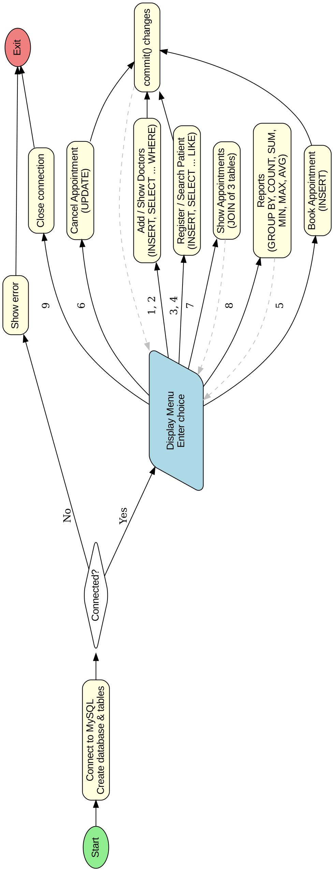

Project Code
# Hospital Management System
# Python + MySQL interface (mysql.connector)
# Tables: doctors, patients, appointments
import mysql.connector
HOST = "localhost"
USER = "root"
PASSWORD = "admin" # change to your MySQL password
DATABASE = "hospital"
def connect_database():
# Create the database (first time) and connect to it
con = mysql.connector.connect(host=HOST, user=USER, password=PASSWORD)
cur = con.cursor()
cur.execute("CREATE DATABASE IF NOT EXISTS " + DATABASE)
con.close()
con = mysql.connector.connect(host=HOST, user=USER,
password=PASSWORD, database=DATABASE)
return con
def create_tables(con):
cur = con.cursor()
cur.execute("""CREATE TABLE IF NOT EXISTS doctors (
doc_id INT PRIMARY KEY,
name VARCHAR(40) NOT NULL,
department VARCHAR(30),
fees INT)""")
cur.execute("""CREATE TABLE IF NOT EXISTS patients (
pat_id INT PRIMARY KEY,
name VARCHAR(40) NOT NULL,
age INT,
gender CHAR(1),
phone VARCHAR(10))""")
cur.execute("""CREATE TABLE IF NOT EXISTS appointments (
app_id INT PRIMARY KEY AUTO_INCREMENT,
pat_id INT,
doc_id INT,
app_date DATE,
status VARCHAR(10) DEFAULT 'Booked',
FOREIGN KEY (pat_id) REFERENCES patients(pat_id),
FOREIGN KEY (doc_id) REFERENCES doctors(doc_id))""")
# Add some doctors the first time so the program can be used at once
cur.execute("SELECT COUNT(*) FROM doctors")
if cur.fetchone()[0] == 0:
doctors = [(101, "Dr. R.K. Sharma", "Cardiology", 800),
(102, "Dr. Meena Joshi", "Pediatrics", 500),
(103, "Dr. Anil Rawat", "Orthopedics", 600),
(104, "Dr. Sunita Bisht", "General", 300),
(105, "Dr. Vikas Pant", "Cardiology", 700)]
cur.executemany("INSERT INTO doctors VALUES (%s, %s, %s, %s)", doctors)
con.commit()
# ---------------- Doctors ----------------
def add_doctor(con):
cur = con.cursor()
doc_id = int(input("Enter Doctor ID: "))
name = input("Enter Doctor Name: ")
dept = input("Enter Department: ")
fees = int(input("Enter Consultation Fees: "))
cur.execute("INSERT INTO doctors VALUES (%s, %s, %s, %s)",
(doc_id, name, dept, fees))
con.commit()
print("Doctor added successfully!")
def show_doctors(con):
cur = con.cursor()
dept = input("Enter Department (press Enter for all): ")
if dept == "":
cur.execute("SELECT * FROM doctors ORDER BY department")
else:
cur.execute("SELECT * FROM doctors WHERE department = %s", (dept,))
rows = cur.fetchall()
if len(rows) == 0:
print("No doctors found.")
return
print("%-6s %-20s %-14s %6s" % ("ID", "Name", "Department", "Fees"))
print("-" * 50)
for r in rows:
print("%-6d %-20s %-14s %6d" % r)
# ---------------- Patients ----------------
def add_patient(con):
cur = con.cursor()
pat_id = int(input("Enter Patient ID: "))
name = input("Enter Patient Name: ")
age = int(input("Enter Age: "))
gender = input("Enter Gender (M/F): ").upper()
phone = input("Enter Phone Number: ")
cur.execute("INSERT INTO patients VALUES (%s, %s, %s, %s, %s)",
(pat_id, name, age, gender, phone))
con.commit()
print("Patient registered successfully!")
def search_patient(con):
cur = con.cursor()
name = input("Enter name (or part of name) to search: ")
cur.execute("SELECT * FROM patients WHERE name LIKE %s", ("%" + name + "%",))
rows = cur.fetchall()
if len(rows) == 0:
print("No patient found.")
return
print("%-6s %-20s %4s %6s %-10s" % ("ID", "Name", "Age", "Gender", "Phone"))
print("-" * 50)
for r in rows:
print("%-6d %-20s %4d %6s %-10s" % r)
# ---------------- Appointments ----------------
def book_appointment(con):
cur = con.cursor()
pat_id = int(input("Enter Patient ID: "))
doc_id = int(input("Enter Doctor ID: "))
app_date = input("Enter Date (YYYY-MM-DD): ")
cur.execute("INSERT INTO appointments (pat_id, doc_id, app_date) VALUES (%s, %s, %s)",
(pat_id, doc_id, app_date))
con.commit()
print("Appointment booked! Appointment ID:", cur.lastrowid)
def cancel_appointment(con):
cur = con.cursor()
app_id = int(input("Enter Appointment ID to cancel: "))
cur.execute("UPDATE appointments SET status = 'Cancelled' WHERE app_id = %s", (app_id,))
con.commit()
if cur.rowcount > 0:
print("Appointment", app_id, "cancelled.")
else:
print("No appointment found with ID", app_id)
def show_appointments(con):
cur = con.cursor()
# JOIN of three tables
cur.execute("""SELECT a.app_id, p.name, d.name, d.department, a.app_date, a.status
FROM appointments a, patients p, doctors d
WHERE a.pat_id = p.pat_id AND a.doc_id = d.doc_id
ORDER BY a.app_date""")
rows = cur.fetchall()
if len(rows) == 0:
print("No appointments found.")
return
print("%-4s %-16s %-18s %-12s %-11s %-9s" %
("ID", "Patient", "Doctor", "Department", "Date", "Status"))
print("-" * 75)
for r in rows:
print("%-4d %-16s %-18s %-12s %-11s %-9s" %
(r[0], r[1], r[2], r[3], str(r[4]), r[5]))
# ---------------- Reports ----------------
def reports(con):
cur = con.cursor()
print("\n--- Appointments per Department (GROUP BY) ---")
cur.execute("""SELECT d.department, COUNT(*)
FROM appointments a, doctors d
WHERE a.doc_id = d.doc_id AND a.status = 'Booked'
GROUP BY d.department""")
for r in cur.fetchall():
print("%-14s : %d" % r)
print("\n--- Fees Collected by each Doctor (SUM) ---")
cur.execute("""SELECT d.name, SUM(d.fees)
FROM appointments a, doctors d
WHERE a.doc_id = d.doc_id AND a.status = 'Booked'
GROUP BY d.name
ORDER BY SUM(d.fees) DESC""")
for r in cur.fetchall():
print("%-20s : Rs. %d" % (r[0], r[1]))
print("\n--- Patient Statistics (MIN, MAX, AVG) ---")
cur.execute("SELECT COUNT(*), MIN(age), MAX(age), AVG(age) FROM patients")
r = cur.fetchone()
print("Total Patients:", r[0])
if r[0] > 0:
print("Youngest:", r[1], "| Oldest:", r[2], "| Average Age:", round(float(r[3]), 1))
def main():
try:
con = connect_database()
except mysql.connector.Error as e:
print("Could not connect to MySQL:", e)
return
create_tables(con)
while True:
print("\n======= HOSPITAL MANAGEMENT SYSTEM =======")
print("1. Add Doctor")
print("2. Show Doctors")
print("3. Register Patient")
print("4. Search Patient")
print("5. Book Appointment")
print("6. Cancel Appointment")
print("7. Show All Appointments")
print("8. Reports")
print("9. Exit")
choice = input("Enter your choice: ")
try:
if choice == "1":
add_doctor(con)
elif choice == "2":
show_doctors(con)
elif choice == "3":
add_patient(con)
elif choice == "4":
search_patient(con)
elif choice == "5":
book_appointment(con)
elif choice == "6":
cancel_appointment(con)
elif choice == "7":
show_appointments(con)
elif choice == "8":
reports(con)
elif choice == "9":
con.close()
print("Database connection closed. Goodbye!")
break
else:
print("Invalid choice! Please try again.")
except ValueError:
print("ERROR: Please enter numbers where required.")
except mysql.connector.Error as e:
print("Database ERROR:", e.msg)
main()

Output

Output 1: Doctors List
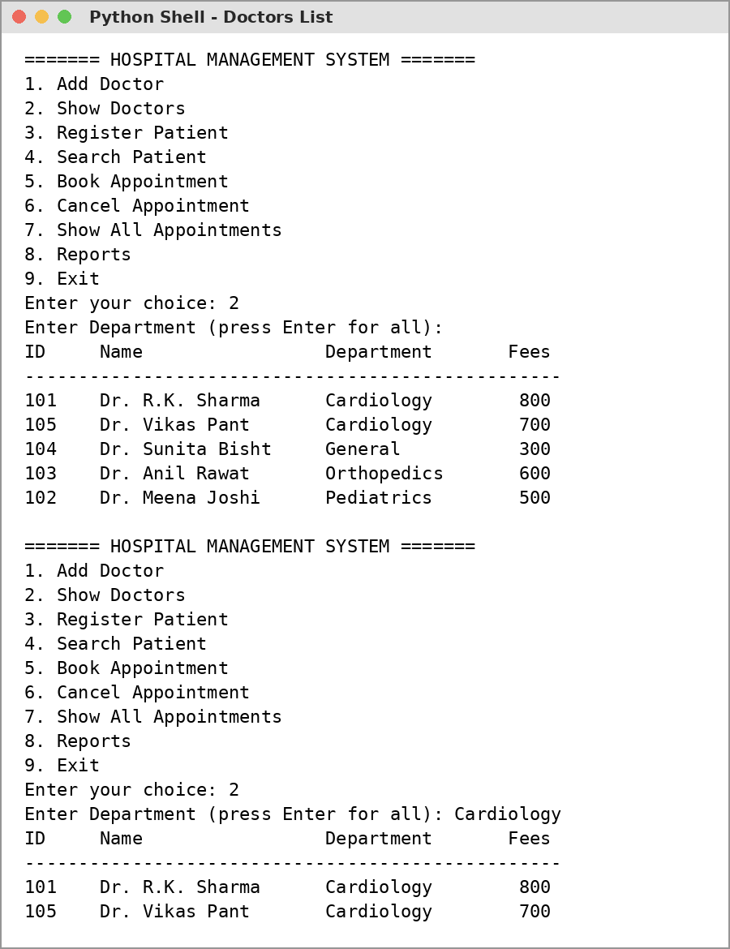

Output 2: Registering Patients
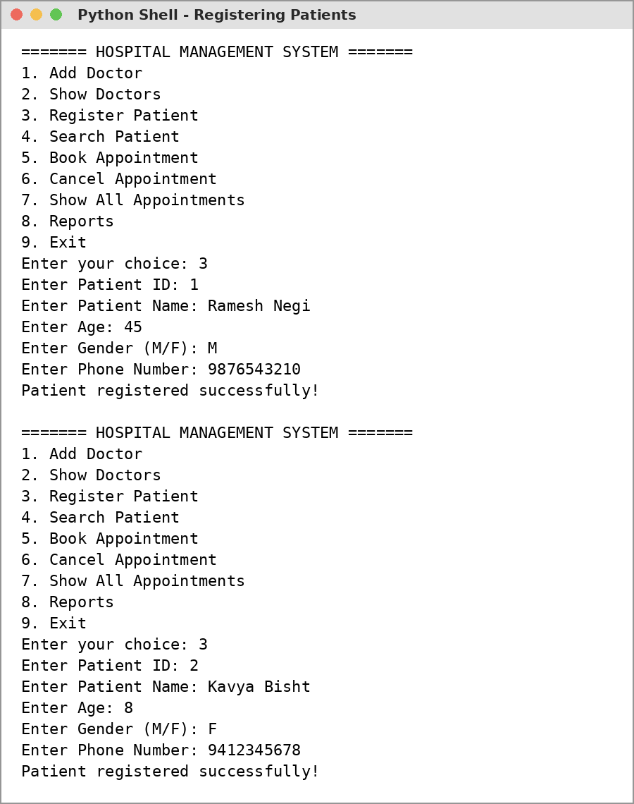

Output 3: More Patients and Duplicate ID Error
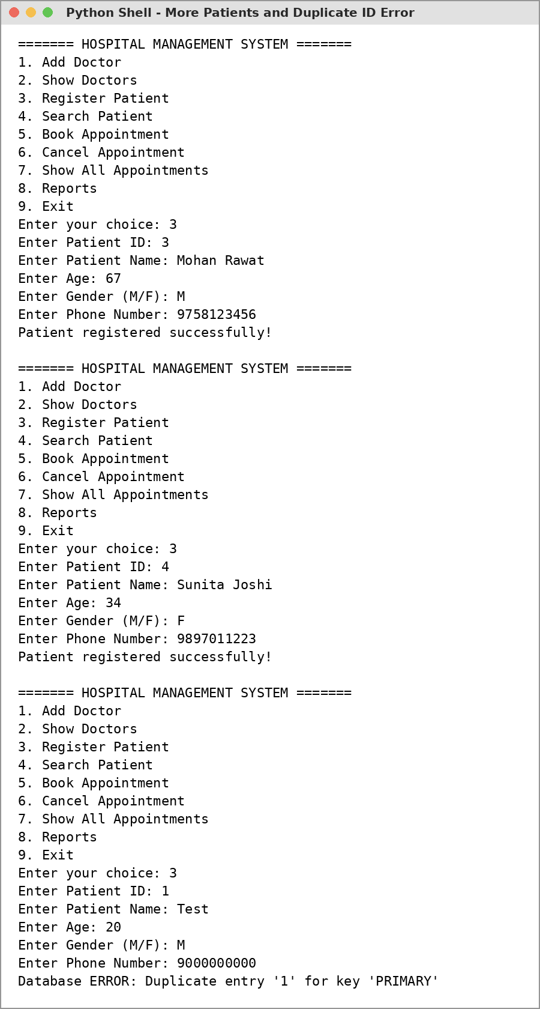

Output 4: Booking Appointments
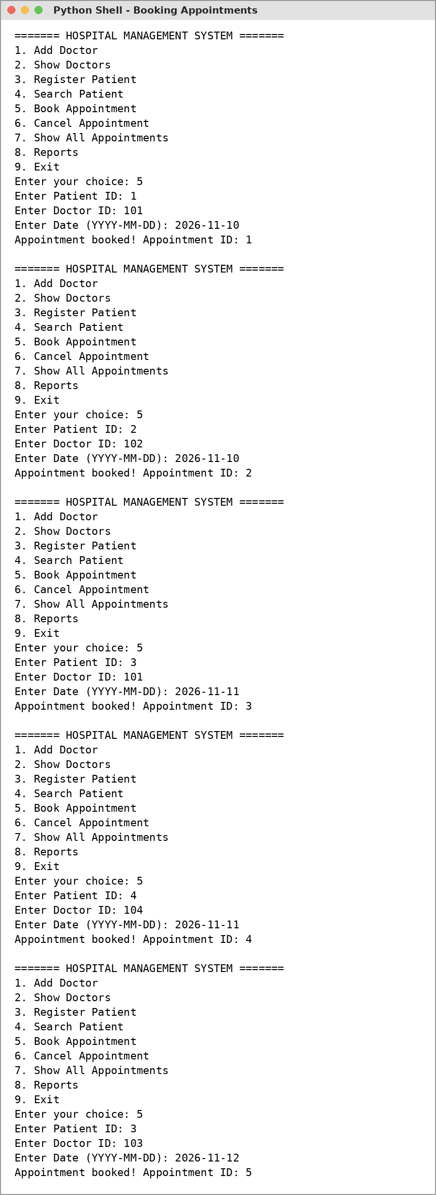

Output 5: Cancel Appointment and Show All (JOIN)
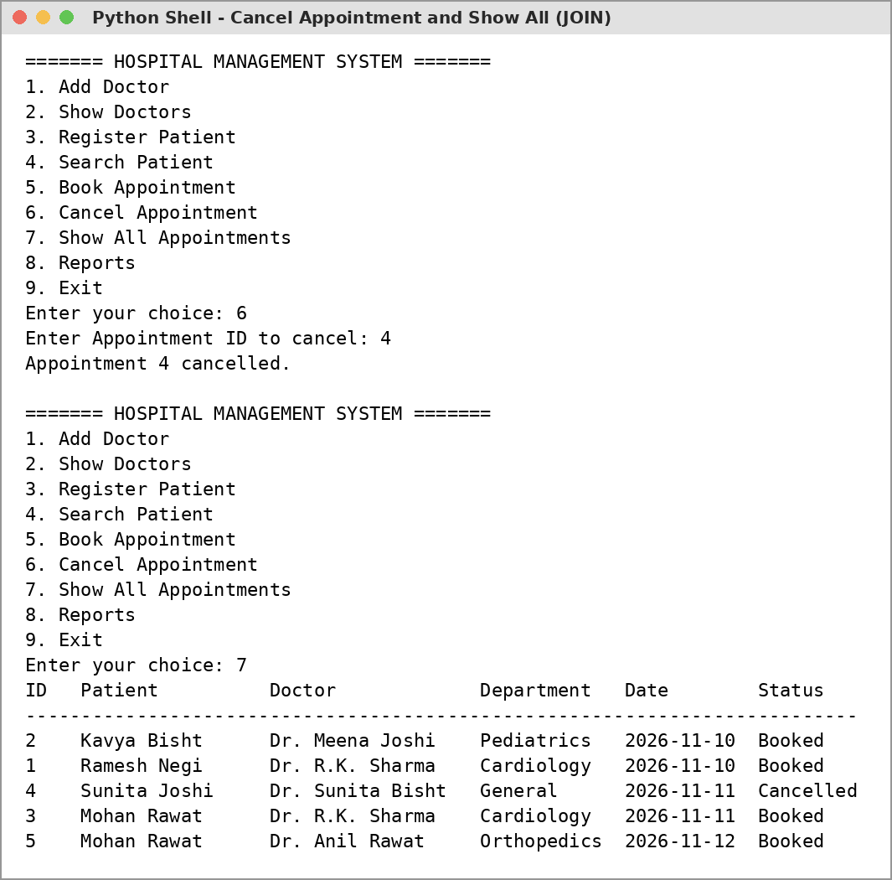

Output 6: Search Patient (LIKE)
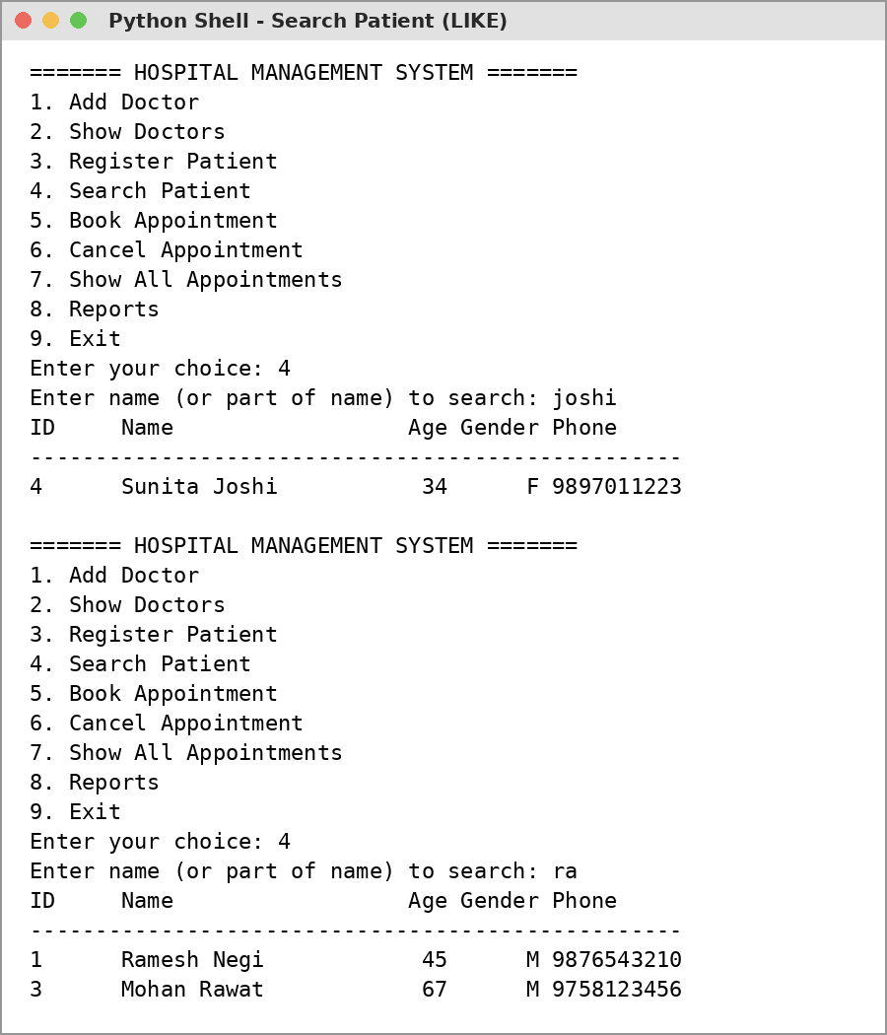

Output 7: Reports (GROUP BY and Aggregate Functions)
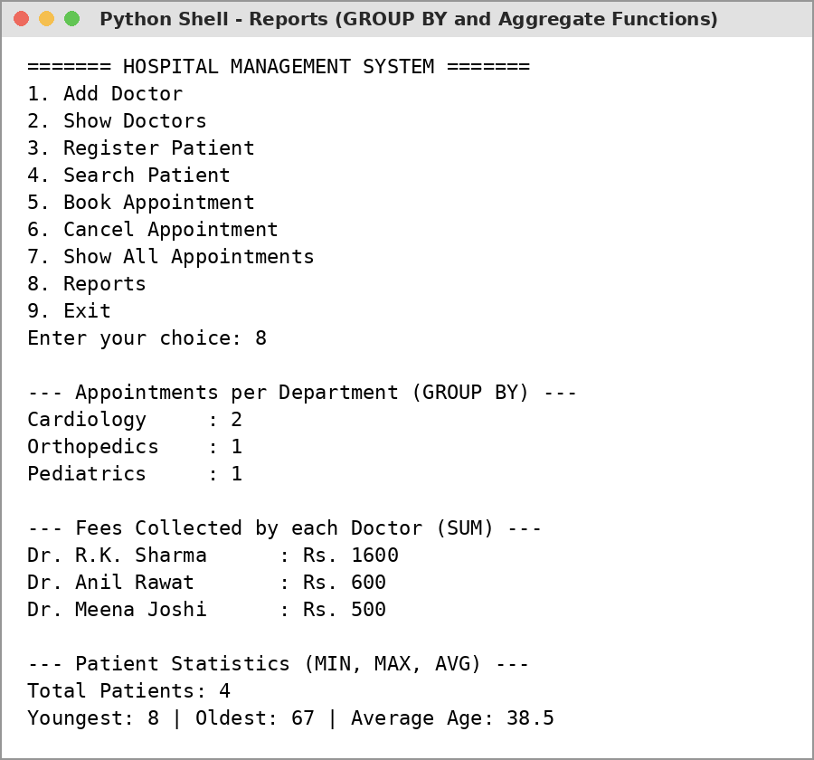

Output 8: Invalid Input and Exit
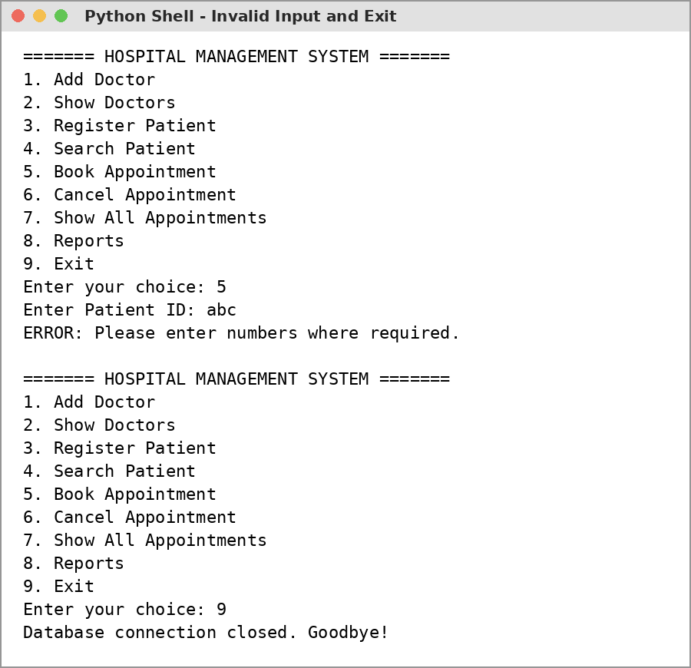

Technological Requirements: Hardware & Software
Software
- Python 3.x (IDLE)
- MySQL Server 8.0
- mysql-connector-python module
- VS Code / any text editor
Hardware
- Laptop / PC with Intel Core i3 or above
- 4 GB RAM or more
- Keyboard and Mouse

References
- Computer Science with Python - Textbook for Class XII (Sumita Arora)
- NCERT Computer Science Textbook for Class XII, Chapters: Database Concepts, SQL
- https://dev.mysql.com/doc/connector-python/en/
- https://www.w3schools.com/python/python_mysql_getstarted.asp
- https://www.w3schools.com/sql/

